ALPHA | RED | GREEN | BLUE
PIXELS

One pixel -- picture element
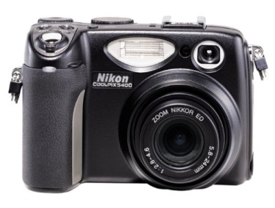

Nikon Coolpix 5400 5.1 MP Digital Camera w/ 4x Optical Zoom
-- 5 megapixel sensor (2592 x 1944 pixels)

Four bytes, 4 sets of 8 bits

ALPHA: Transparency -- 0 is completely transparent, 255 is completely opaque

RED: value of red, 0 – 255

GREEN: value of green, 0 – 255

BLUE: value of blue, 0 – 255

Lots of pixels! How many bits???

